POINTER

Pointer is a variable that store the address of other variable.

How declare a pointer?

int *pointVar;

we can also declare pointer ,

int* pointVar; // preferred syntax

example:

int* pointVar, p;

here **pointVar** is a pointer and **p** is a normal integer.

Assigning addresses to pointers:

int* pointVar, var;

var = 5;

// assign address of var to pointVar pointer

pointVar = &var;

Here, 5 is assigned to the variable var. And, the address of var is assigned to the pointVar pointer with the code pointVar = &var.

Or,

Char type pointers,

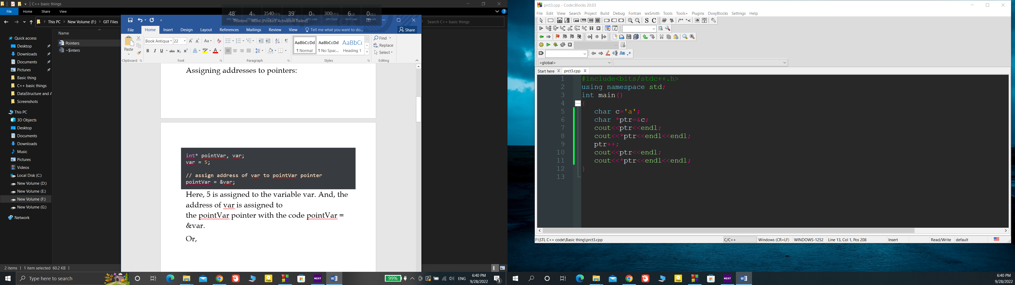

Output:

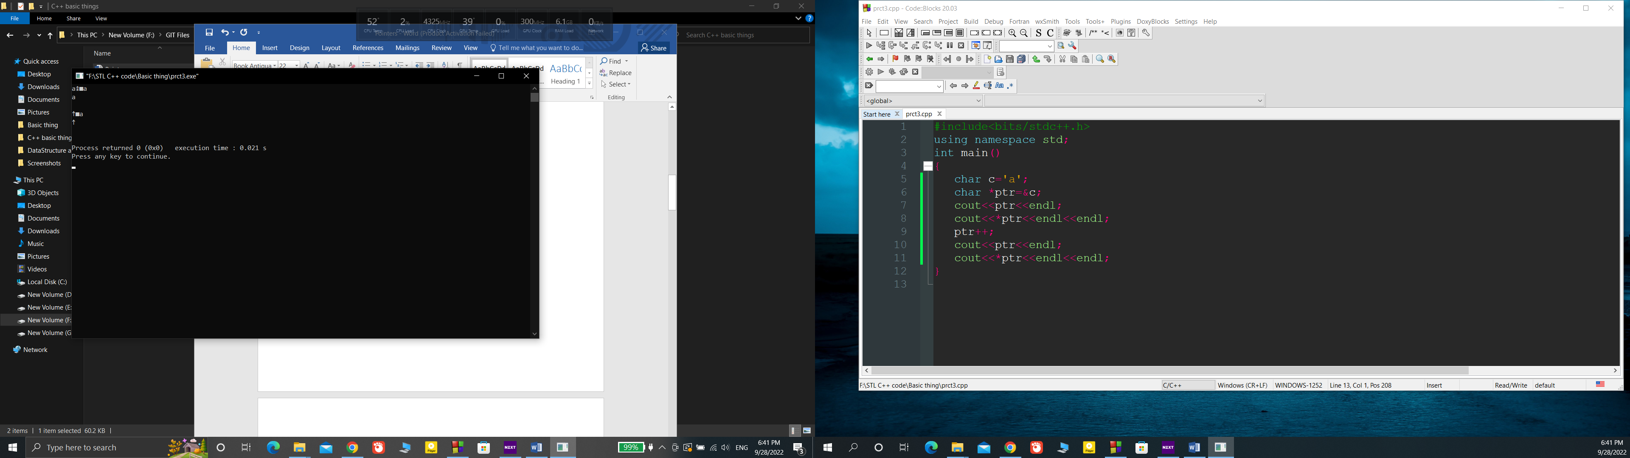

Again,

int* pointVar, var;

var = 5;

// assign address of var to pointVar

pointVar = &var;

// access value pointed by pointVar

cout << *pointVar << endl; // Output: 5

pointVar is assigning the address of var .

and *pointVar is the value that is stored in the address of pointVar

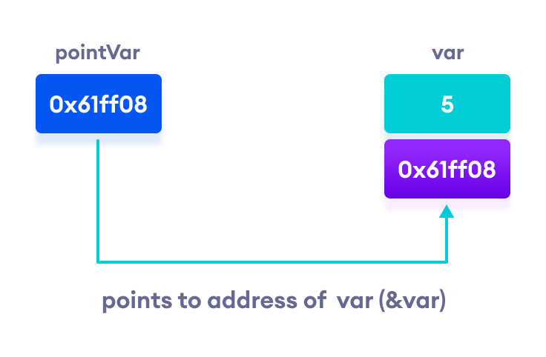

***ARRAYS AND POINTERS***

How to print array using pointer :

Code:

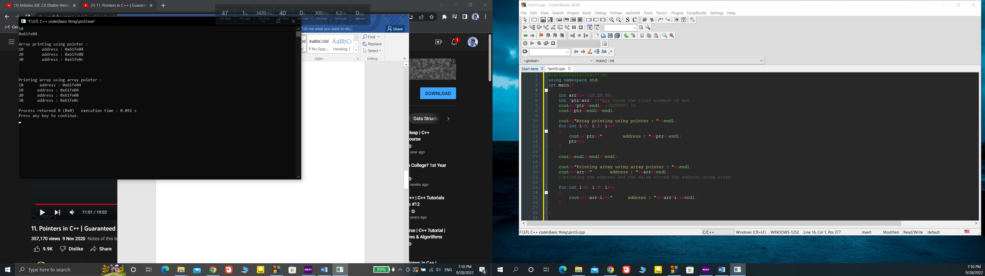

Output:



Swaping two number using pass by reference:  
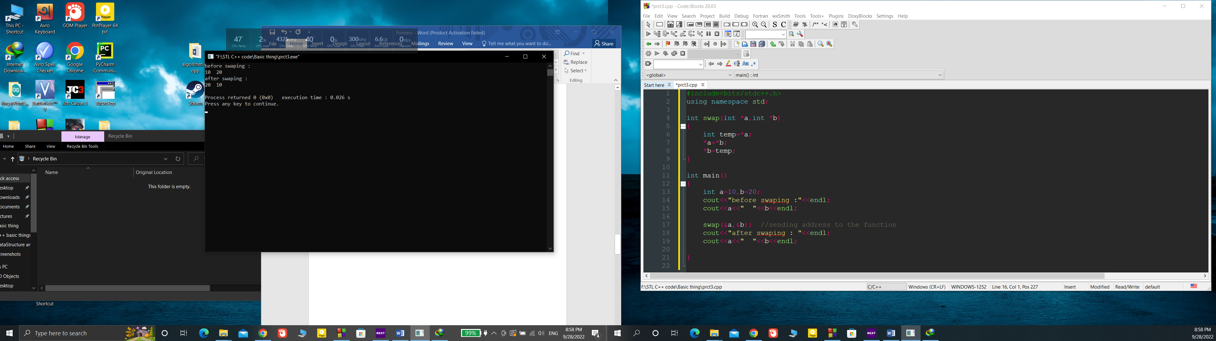

OUTPUT:

